R. CACCIAMANI1, S. COLELLA1, A. SANTOJANNI1

1Institute for Marine Biological Resources and Biotechnologies,

National Research Council (IRBIM-CNR), Ancona, Italy

[roberto.cacciamani@irbim.cnr.it](mailto:roberto.cacciamani@irbim.cnr.it)

**PRELIMINARY STUDY ON THE EFFECT OF HABITAT CONDITIONS ON REPRODUCTION OF SMALL PELAGIC FISH IN THE MIDDLE ADRIATIC SEA**

***STUDIO PRELIMINARE SUGLI EFFETTI DELLE CONDIZIONI DELL’HABITAT SULLA RIPRODUZIONE DEI PICCOLI PELAGICI NEL MEDIO ADRIATICO***

**Abstract** – *This study aims to describe the reproductive cycle of small pelagic fish in the Central Adriatic Sea and investigate if environmental factors influence intra- and inter-annual reproductive trait variations. Biological data were collected from mid-water pelagic trawl commercial catches landed in Ancona in 3 different years (2001, 2011, 2022). Environmental data were obtained from the Copernicus Marine Environment Monitoring Service. Results showed that anchovy and sardine spawning intensity, denoted by the gonadosomatic index, did not exhibit any inter-annual changes. Regarding sardine, the negative correlation between gonadal development and temperature confirms its preference for cold waters to spawn. Conversely, a positive correlation with chlorophyll a suggests a reproductive strategy to ensure food availability for juvenile stages.* *These are the outcomes of a preliminary study; further analysis on a longer time series could help to deepen the effects of habitat conditions on reproduction of small pelagics in the Adriatic Sea.*

***Key-words****: Small pelagic fish, Gonadosomatic Index, Sea Surface Temperature, Chlorophyll a, Adriatic Sea.*

**Introduction** - Small pelagic fish, European anchovy (*Engraulis encrasicolus*, Linnaeus, 1758) and European sardine (*Sardina pilchardus*, Walbaum, 1792), are among the most important commercial species of the Adriatic Sea (Santojanni *et al*., 2006). In 2020, they accounted for 34% of total catches in GSA17 and 18 (source EU-DCF database 2020; European Commission (EC), 2017). Their importance is not only related to the socio-economic value, but also to the ecological role played in marine ecosystems: they exert a top-down control on zooplankton and bottom-up control on top predators, acting like “wasp-waist” species (Cury *et al*., 2000, Caballero-Huertas *et al*., 2023). Their short life span and great susceptibility to environmental variability and physical processes caused, in recent decades, strong fluctuations of biomass of these species (Brosset *et al*., 2017). In recent years, a general decrease of small pelagic fish stocks has been observed in various parts of the Mediterranean (Caballero-Huertas *et al*., 2023), which led to fishery crisis. The sudden collapse of pelagic fisheries can be attributed to a combination of factors, including environmental influence, interactions with other species, and overexploitation. Notably, environmental variability often exerts an influence on the life history traits of fish, such as size/growth, somatic condition, and fecundity. These aspects are extensively studied as they play a relevant role into the dynamics of fish populations (Caballero-Huertas *et al*. 2023). In this regard, the present study aimed to describe the reproductive cycle of the small pelagic fish in the Central Adriatic Sea (GSA 17) by means of investigating Gonadosomatic Index (GSI) intra- and inter-annual fluctuations and the possible role of environmental factors.

**Materials and methods** - Biological data were collected monthly from commercial landings of mid-water pelagic pair trawlers landed in Ancona port. A total of 960 anchovy and 826 sardine samples were analysed monthly in 3 different years over a 21-years period (2001, 2011, 2022). The total length (TL, measured to the nearest half cm below), total body weight (W, 0.1 g accuracy) and gonad weights (WG, 0.001 g accuracy) of each specimen were measured. Sex and maturity stages of gonads were macroscopically evaluated according to ICES maturity scale (ICES, 2008). The reproductive cycle was determined by evaluating the Gonadosomatic Index (GSI) calculated monthly and seasonally, according to the following equation:

GSI = Gonad weight(g)/Total body weight (g) * 100 (Pacetti *et al*., 2013).

Mean monthly chlorophyll a concentration (chla, mg/m³) and Sea Surface Temperature (SST, °C) were provided by the Copernicus Marine Environment Monitoring Service (CMEMS program, https://data.marine.copernicus.eu/products). Kendall rank correlation coefficient (τ) was calculated to check the collinearity among GSI and Chlorophyll a, SST and time; the influence of these variables on the reproduction was tested through a simple linear model (LM).

**Results** - GSIs reached their peak respectively in spring and summer seasons for the anchovy and winter and spring seasons for the sardine, in all the years considered.

Tab. 1 - Kendall rank correlation coefficient and linear model results between small pelagics gonadosomatic index and sea surface temperature (SST), Chlorophyll a and time variables.

*Risultati del coefficiente di correlazione di Kendall e del modello lineare tra l’indice gonadosomatico dei piccoli pelagici e le variabili temperatura superficiale marina (SST), clorofilla a e tempo.*

|  |  |  |  |  |
| --- | --- | --- | --- | --- |
| **Variables** | **Kendall** | | **Linear model** | |
| **Anchovy** | **p-value** | **τ** | **p-value** | **r²** |
| GSI – Time (months) | >0.05 | -0.206 | >0.05 | 0.055 |
| GSI - SST | >0.05 | 0.193 | >0.05 | 0.089 |
| GSI – Chlorophyll a | **<0.05** | **-0.27** | **<0.05** | **0.165** |
| **Sardine** |  |  |  |  |
| GSI – Time (months) | >0.05 | -0.141 | >0.05 | 0.044 |
| GSI - SST | **<0.05** | **-0.552** | **<0.05** | **0.656** |
| GSI – Chlorophyll a | **<0.05** | **0.448** | **<0.05** | **0.392** |

Kendall correlation test does not show any collinearity between this index and the variable “Time” both for anchovy and sardine (p-value > 0.05, Tab. 1); also the linear model does not indicate any effect of time on the reproductive cycle of the small pelagics (p-value > 0.05, Tab. 1). The SST values vary between the mean of 11.6 °C of March 2011 and 26.4 °C of July 2022. This variable does not show any collinearity or influence on anchovy GSI (p-value > 0.05, Tab. 1); on the other hand, it seems to have a significant inverse relationship with sardine gonadal maturation, indicating that as the temperature increases, the GSI decreases (p-value < 0.05, Tab.1) and vice-versa. Linear model validates the correlation between the variables (p-value < 0.05, Tab.1). Regarding Chlorophyll a, a slightly inverse relationship (p-value < 0.05, Tab.1) and a low but significant effect (p-value < 0.05, Tab.1) is detected for anchovy GSI; this variable has a stronger direct relationship on sardine gonadal maturation (p-value < 0.05, Tab.1). Statistical analysis did not show any significant changes of small pelagics GSI over the 3 years. Nonetheless, anchovy shows some differences in gonadal development through the investigated period; in particular, a general decrease of GSI in 2022 can be noticed (Fig. 1), while the line plot highlights a gradual decrease of GSI peaks over the years.

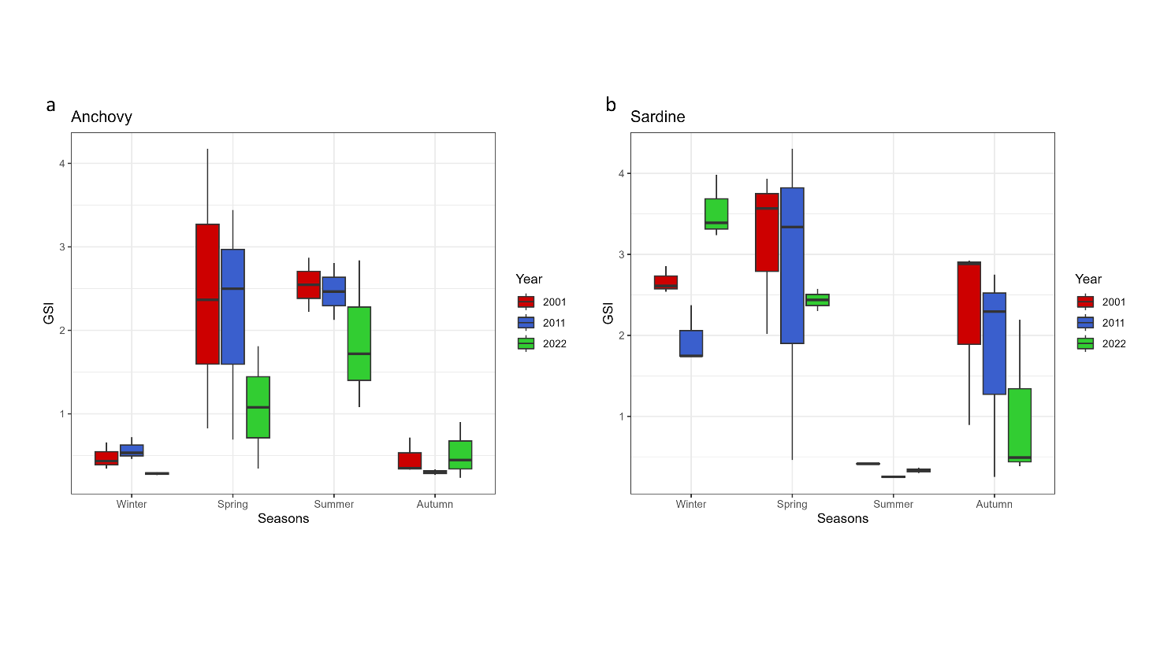Fig. 1 - (a) Box-plot of the seasonal variation of anchovy GSI; (b) Box-plot of the seasonal variation of anchovy GSI.

*(a) Box-plot della variazione stagionale del GSI dell’acciuga; (b) Box-plot della variazione stagionale del GSI della sardina.*

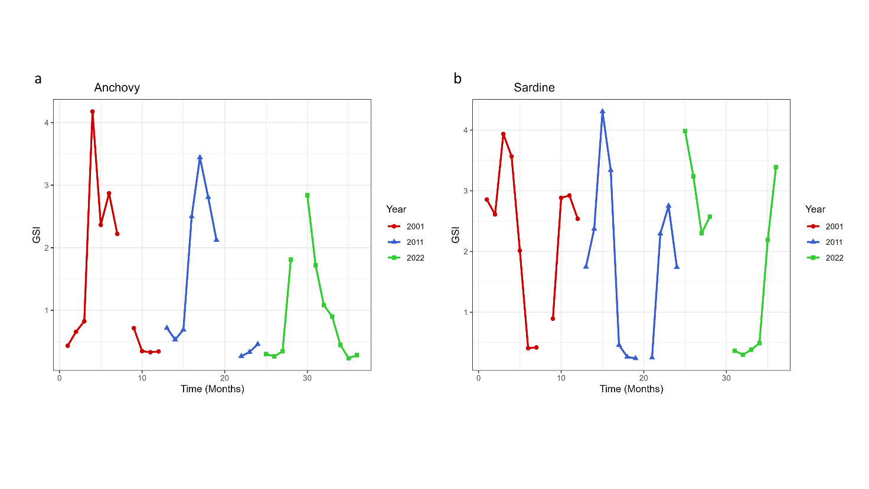Fig. 2 - Line-plots of the variation of anchovy (a) and sardine (b) GSI over time (months and years).

*Grafici a linee della variazione del GSI dell’acciuga (a) e della sardina (b) nell’arco dell’anno.*

**Conclusions** - The results of the present study are consistent with a marked reduction of anchovy spawning stock biomass estimated in the latest assessments and a general decrease in body condition of the species observed by Brosset *et al*., 2017 within the same period. Regarding sardine, a shift in gonadal development seasonality can be assumed in light of the observed inter-annual variations; further analysis is therefore needed to evaluate such hypothesis.

Sea surface temperature is considered one of main drivers that regulates small pelagics spawning in the Adriatic Sea (Fernández-Corredor *et al*., 2021). Present results are consistent with several previous works on sardine reproduction (Brosset *et al*., 2017, Fernández-Corredor *et al*., 2021, Caballero-Huertas *et al*., 2023), since GSI increase seems to be considerably affected by the decrease of the SST. In this species, in fact, spawning seems to be triggered by the decline in water temperatures and wanes as temperatures rise. Conversely, a positive correlation between spawning intensity and Chlorophyll a emerged in this analysis for sardine, while it was very low and negative in anchovy. The influence of Chlorophyll a on sardine reproduction can be attributed to the presence of diatoms in sardine diet, unlike anchovy (Brosset *et al*., 2017). It can also reflect a direct transfer of energy from the consumption of phytoplankton to the reproductive process, or a strategy to maximize the reproduction success granting favorable environmental conditions to the progeny (Fernández-Corredor *et al*., 2021). The results presented here, although preliminary, have the purpose to study the variations of small pelagics reproductive cycle over a long period, and obtain a better understanding of the effects of the environment on their spawning intensity and seasonality.

**References**

BROSSET P., FROMENTIN J-M., VAN BEVEREN E., LLORET J., MARQUES V., BASILONE G., BONANNO A., CARPI P., DONATO F., KEČ V.C., DE FELICE A., FERRERI R., GAŠPAREVIĆ D., GIRÁLDEZ A., GÜCÜ A., IGLESIAS M., LEONORI I., PALOMERA I., SOMARAKIS S., TIČINA V., TORRES P., VENTERO A., ZORICA B., MÉNARD F., SARAUX C. (2017) - Spatio-temporal patterns and environmental controls of small pelagic fish body condition from contrasted Mediterranean areas. *Prog. Oceanogr.,* **151**: 149-162.

CABALLERO-HUERTAS M., FRIGOLA-TEPE X., VIÑAS J. AND MUÑOZ M. (2023) - From west to east: Heterogeneity in the life history traits of a small pelagic fish (*Sardina pilchardus*) throughout the Mediterranean. *Front. Mar. Sci.*, **10**: 1187071.

CURY P., BAKUN A., CRAWFORD R.J.M., JARRE A., QUINONES R.A., SHANNON L.J., VERHEYE H.M. (2000) - Small pelagics in upwelling systems: patterns of interaction and structural changes in “wasp-waist” ecosystems. *ICES J. Mar. Sci.*, **57** (3): 603–618.

EUROPEAN COMMISSION (EC) (2017) - Regulation (EU) 2017/1004 on the Establishment of a Union Framework for the Collection, Management and Use of Data in the Fisheries Sector and Support for Scientific Advice Regarding the Common Fisheries Policy and Repealing Council Regulation (EC) No 199/2008. Brussels: European Commission.

FERNÁNDEZ-CORREDOR E., ALBO-PUIGSERVER M., PENNINO M.G., BELLIDO J.M., COLL M. (2021) - Influence of environmental factors on different life stages of European anchovy (*Engraulis encrasicolus*) and European sardine (*Sardina pilchardus*) from the Mediterranean Sea: A literature review. *Reg. Stud. Mar. Sci*., **41**: 101606.

ICES (2008) - Report of the Workshop on Small Pelagics *(Sardina pilchardus, Engraulis encrasicolus*) maturity stages (WKSPMAT), 10–14 November 2008, Mazara del Vallo, Italy. ICES CM 2008/ACOM:40. 82 pp.

PACETTI D., BALZANO M., COLELLA S., SANTOJANNI A., FREGA N. G. (2013) - Effect of Spawning on Furan Fatty Acid Profile of Edible Muscle and Organ Tissues from Sardine (*Sardina pilchardus*) and Anchovy (*Engraulis encrasicolus*). *J. Agric. Food Chem.*, **61**(16): 3969–3977.

SANTOJANNI A., ARNERI E., BERNARDINI V., CINGOLANI N., DI MARCO M., RUSSO, A. (2006) - Effects of environmental variables on recruitment of anchovy in the Adriatic Sea. *Clim. Res.*, **31**: 181–193.